**Create Splash Screen and Custom Icon**

**Reference Link :** [**https://www.youtube.com/watch?v=_hgsAlPTGXY&ab_channel=CodeWithAbdul**](https://www.youtube.com/watch?v=_hgsAlPTGXY&ab_channel=CodeWithAbdul)

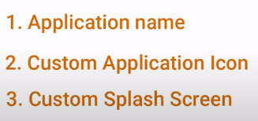

**Step 1**

Create React Native Project

>>> npx react-native init SplashScreen_CustomIcon_08



**Step 2**

Create application Icon Bundle

<https://icon.kitchen/i/H4sIAAAAAAAAA6tWKkvMKU0tVrKqVkpJLMoOyUjNTVWySkvMKU6t1VHKzU8pzQHJRisl5qUU5WemKOkoZeYXA8ny1CSl2FoApT8%2BHkAAAAA%3D>

You can create your custom icon for free

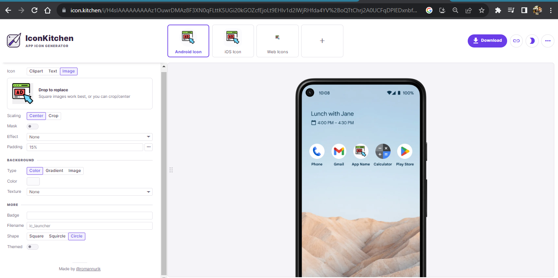

And download

**Step 3**

Unzip the downloaded bundle

And see icons are generated for android ios and web

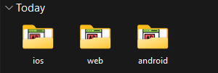

Open android folder folder

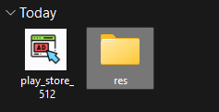

Open src and copy all minmap folder except **mipmap-anydpi-v26**

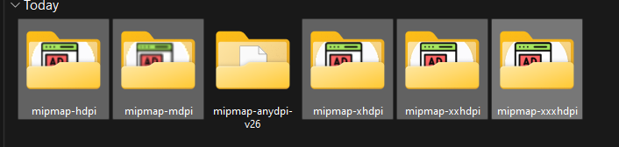

**Step 4**

Open Vs code and navigate

Android -> app -> src -> main -> res

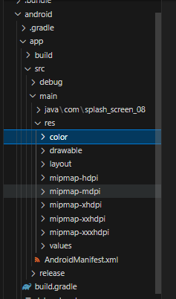

Replace all Minmap folder with downloaded icons

Open res path in folder

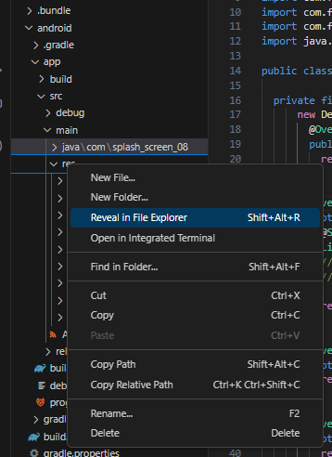

Delete Existing mipmap and paste copied

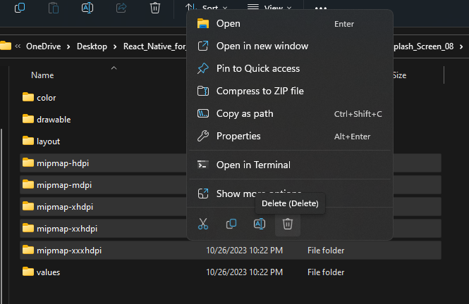

**Step 5**

Goto **android Manifest.xml**

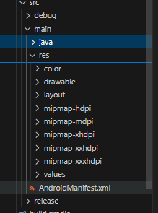

Open AndroidManifes.xml and remove

android:roundIcon="@mipmap/ic_launcher_round"

Line no 9

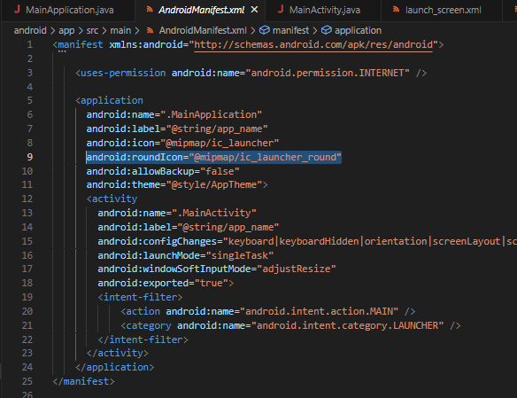

Now Start the app

>>> npx react-native start



App Icon Implemented successfully

**Step 6**

Implement Splash Screen

Generate Splash Screen **assets**

Goto Google and search **apetools**



Open This link

And Click on Generate Your Icons and Splash Screens

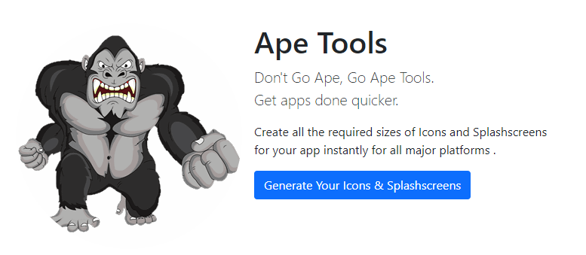

We need to generate a Splash Screen **Upload a image**

Recommended image dimensions are (4096 x 4096 )

And Recommended Resolutions ( 72 x 72 )

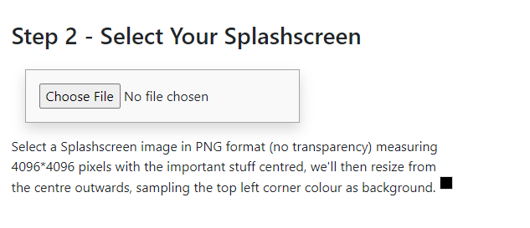

After Uplaod an image check android and click **Kapow** button

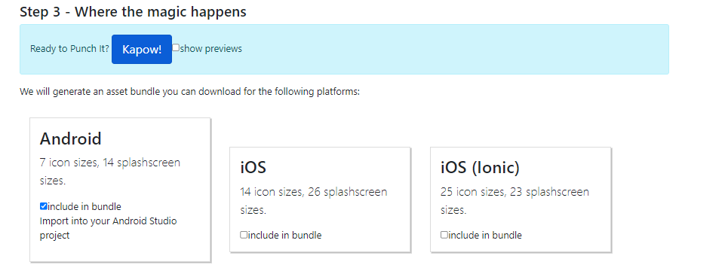

And after processing Download the zip

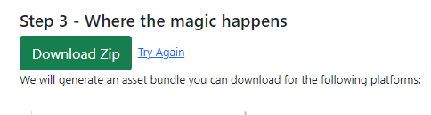

Extract The Downloaded zip

Inside the Extracted folder inside you can find the Splash Screen

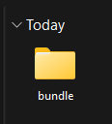 => 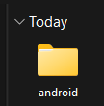 =>

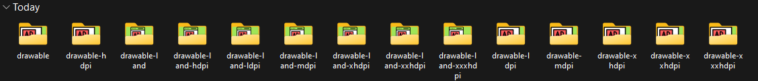

Step 7

Goto Google and search **react-native-splash-screen**

And open the Link

Link : <https://www.npmjs.com/package/react-native-splash-screen>

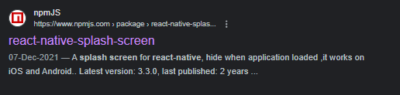

Follow the installation Steps

And follow the instruction or below Gihub instructions

Github : <https://github.com/crazycodeboy/react-native-splash-screen>

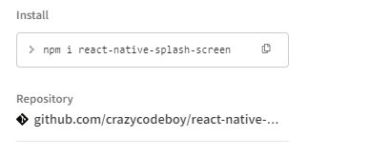

Or follow Below Website Instructions

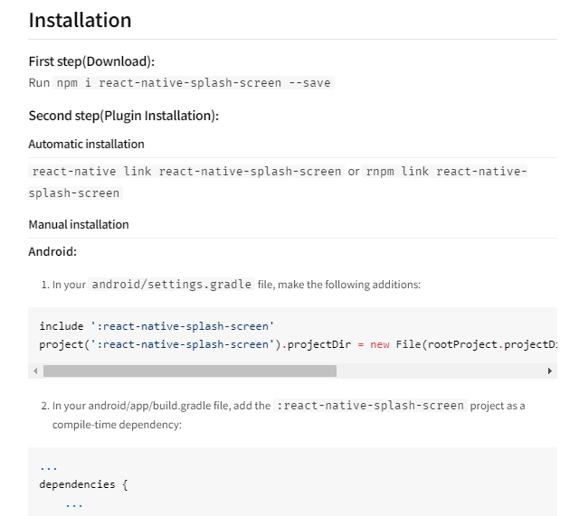

Copy the command and follow the instructions

>>> npm i react-native-splash-screen



>>> npm link react-native-splash-screen

Step 8

After Library Installation Open Vs code and made some changes in android

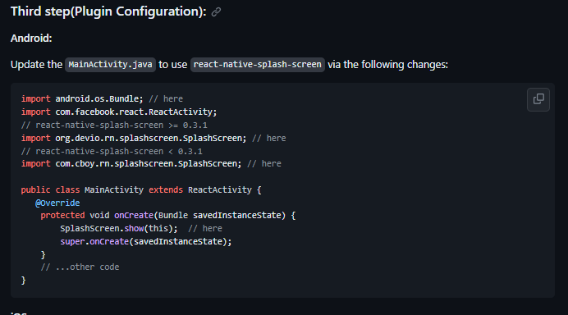

Open Android -> app -> src -> main -> java -> MainActivity.java

And made changes as per installations

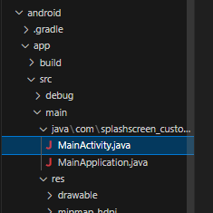

MainActivity.java

package com.splashscreen_customicon_08;

import android.os.Bundle; // here

import org.devio.rn.splashscreen.SplashScreen; // here

import com.facebook.react.ReactActivity;

import com.facebook.react.ReactActivityDelegate;

import com.facebook.react.defaults.DefaultNewArchitectureEntryPoint;

import com.facebook.react.defaults.DefaultReactActivityDelegate;

public class MainActivity extends ReactActivity {

  @Override

    protected void onCreate(Bundle savedInstanceState) {

        SplashScreen.show(this);  // here

        super.onCreate(savedInstanceState);

    }

  /**

   * Returns the name of the main component registered from JavaScript. This is used to schedule

   * rendering of the component.

   */

  @Override

  protected String getMainComponentName() {

    return "SplashScreen_CustomIcon_08";

  }

  /**

   * Returns the instance of the {@link ReactActivityDelegate}. Here we use a util class {@link

   * DefaultReactActivityDelegate} which allows you to easily enable Fabric and Concurrent React

   * (aka React 18) with two boolean flags.

   */

  @Override

  protected ReactActivityDelegate createReactActivityDelegate() {

    return new DefaultReactActivityDelegate(

        this,

        getMainComponentName(),

        // If you opted-in for the New Architecture, we enable the Fabric Renderer.

        DefaultNewArchitectureEntryPoint.getFabricEnabled());

  }

}

Step 9

Import Splach Screen in your Js file

Create a file called launcg)screen.xml in

android -> app -> src -> main -> res -> layout (create the layout folder it does not exists )

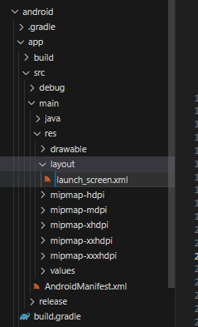

Add

Launch_screen.xml

<?xml version="1.0" encoding="utf-8"?>

<RelativeLayout xmlns:android="http://schemas.android.com/apk/res/android"

android:orientation="vertical" android:layout_width="match_parent"

android:layout_height="match_parent">

<ImageView android:layout_width="match_parent" android:layout_height="match_parent" android:src="@drawable/launch_screen" android:scaleType="centerCrop" />

</RelativeLayout>

Now Open **Styles.xml** inside **values** folder

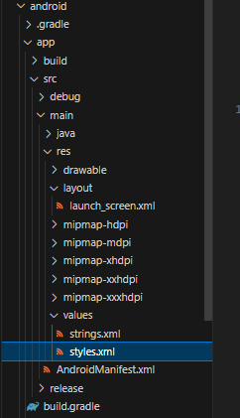

And replace

**@drawable/rn_edit_text_material** to **@layout/lauch_screen**

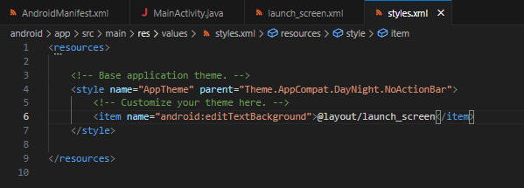

Step 10

Place **Generated Splash Screen** folder

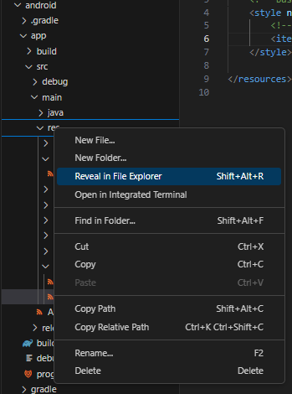

Open res folder

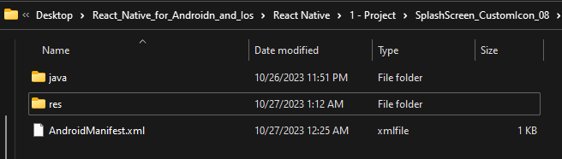

Open paste all the generated drawable her

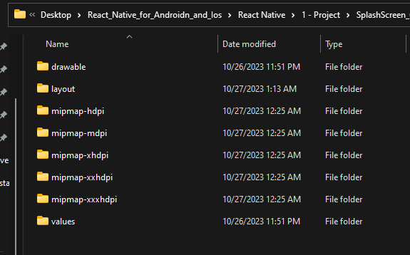

Copy all generated drawable

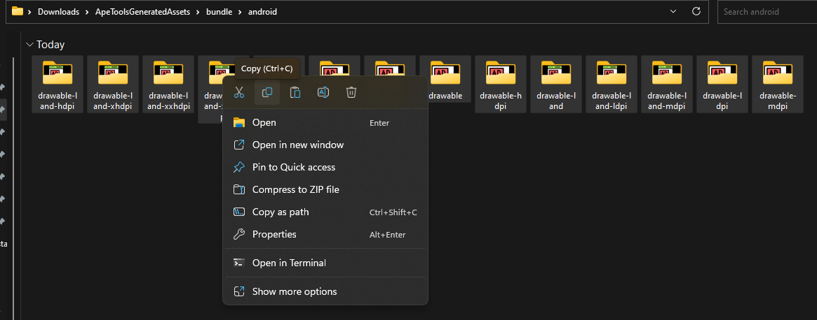

And paste inside **android -> app -> src -> main -> res**

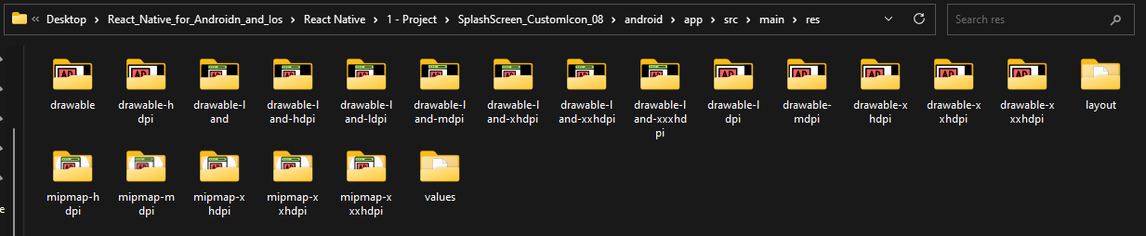

**Step 11**

Edit **Launch_screen.xml** file

and change **/lanch_screen** to **screen as per Drawablle folder png image name**

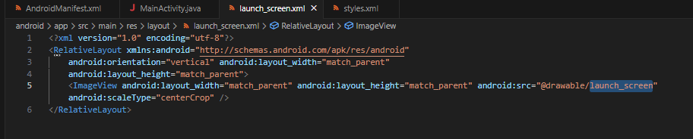

**After changes**

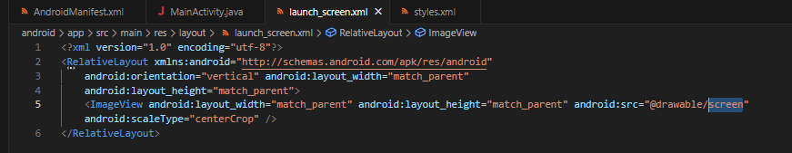

**Step 12**

Goto the **App.js**

And add splash screen

import React, { useEffect } from 'react'

import { Text, View } from 'react-native'

import SplashScreen from 'react-native-splash-screen'

const App = () => {

  useEffect(() => {

    // do stuff while splash screen is shown

    // After having done stuff (such as async tasks) hide the splash screen

    SplashScreen.hide();

  }, [])

  return (

    <View>

      <Text>My App</Text>

    </View>

  )

}

export default App

And rebuild the code

>>> npx react-native start